OpenShift Service Mesh

Deployment, Traffic Management & Observability

Using Istio (Sail Operator) on Red Hat OpenShift
Description:
deploying Red Hat OpenShift Service Mesh 3 (OSSM 3) on an OpenShift cluster, configuring the Bookinfo sample application, and verifying traffic management capabilities including canary routing

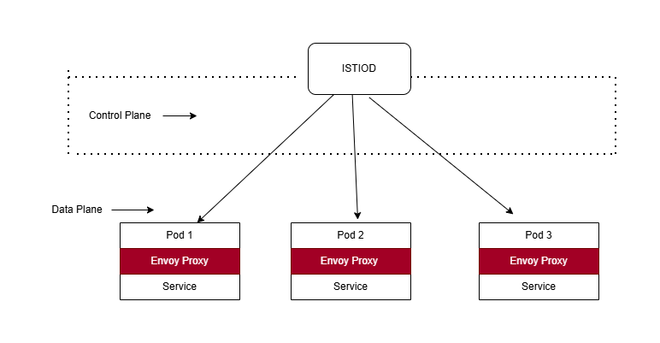

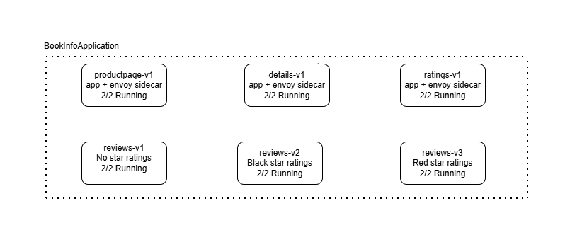

https://raw.githubusercontent.com/istio/istio/release-1.24/samples/bookinfo/platform/kube/bookinfo.yaml

Step 1: Install the Required Operators
You need 4 operators installed in this order via OperatorHub:
1. OpenShift Elasticsearch Operator
2. Red Hat OpenShift distributed tracing platform (Jaeger)
3. Kiali Operator (provided by Red Hat)
4. Red Hat OpenShift Service Mesh
5. Red Hat sail operator.

Confirm the Sail Operator CRDs are present before proceeding
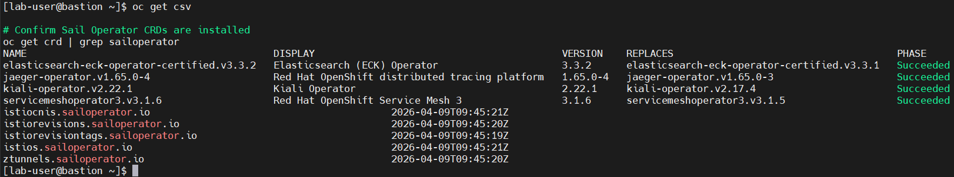

Step 2 — Create the Istio Control Plane

# Create the control plane namespace
oc new-project istio-system
# Deploy the Istio control plane
cat controlplane.yaml
apiVersion: sailoperator.io/v1
kind: Istio
metadata:
name: default
spec:
version: v1.24.3
namespace: istio-system
updateStrategy:
type: InPlace

# Watch until STATUS = Healthy
oc get istio -w

Step 3 — Deploy the IstioCNI Plugin
The CNI plugin must be deployed in its own namespace. Create the namespace first, then apply the IstioCNI resource:
# Create the CNI namespace FIRST (required before applying IstioCNI)
oc new-project istio-cni

# Deploy the CNI plugin
cat cni-plugin.yaml
apiVersion: sailoperator.io/v1
kind: IstioCNI
metadata:
name: default
spec:
version: v1.24.3
namespace: istio-cni

# Watch until READY = True and STATUS = Healthy
oc get istiocni -w

Step 4 — Verify Control Plane Health
Confirm istiod is running and the IstioRevision is healthy before deploying the application:
# Verify istiod pod is running
oc get pods -n istio-system

# Verify IstioRevision
oc get istiorevision -n istio-system
# Full health check
oc get istio && oc get istiocni

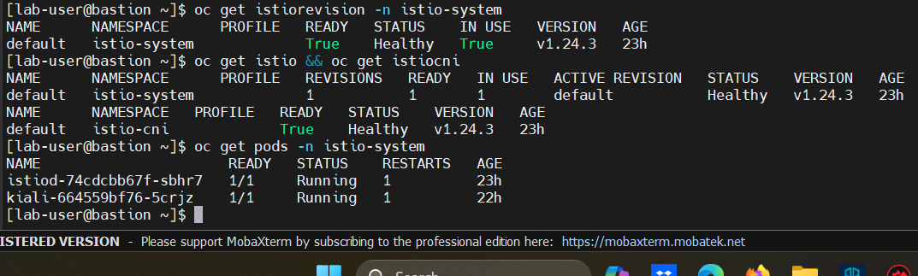

Step 5 — Deploy the Ingress Gateway
In OSSM 3 the ingress gateway is not deployed automatically and must be created manually:
# Create ingress namespace
oc new-project istio-ingress

# Deploy gateway deployment, service, and expose via OpenShift Route
Cat ingressgateway.yaml
apiVersion: apps/v1
kind: Deployment
metadata:
name: istio-ingressgateway
namespace: istio-ingress
spec:
selector:
matchLabels:
istio: ingressgateway
template:
metadata:
annotations:
inject.istio.io/templates: gateway
labels:
istio: ingressgateway
sidecar.istio.io/inject: "true"
spec:
containers:
- name: istio-proxy
image: auto

Cat ingressgateway-svc.yaml
apiVersion: v1
kind: Service
metadata:
name: istio-ingressgateway
namespace: istio-ingress
spec:
type: LoadBalancer
selector:
istio: ingressgateway
ports:
- name: http2
port: 80
targetPort: 8080
- name: https
port: 443
targetPort: 8443

# Expose via OpenShift Route (EXTERNAL-IP will remain <pending> on bare-metal)
oc expose svc istio-ingressgateway -n istio-ingress --port=http2
# Get the Route URL
GATEWAY_URL=$(oc get route istio-ingressgateway -n istio-ingress -o jsonpath='{.spec.host}')
echo $GATEWAY_URL

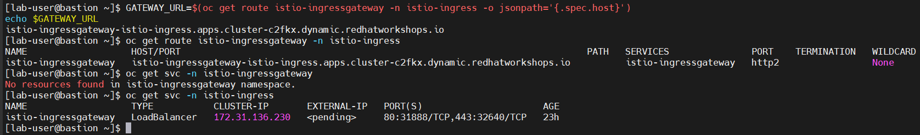

Step 6 — Deploy the Bookinfo Application
Create the bookinfo namespace, enable sidecar injection, and deploy the application:
# Create namespace and enable sidecar injection
oc new-project bookinfo
oc label namespace bookinfo istio-injection=enabled
s
# Deploy Bookinfo from upstream Istio release-1.24
oc apply -n bookinfo -f \
https://raw.githubusercontent.com/istio/istio/release-1.24/samples/bookinfo/platform/kube/bookinfo.yaml

# Verify all 6 pods show 2/2 (app + sidecar)
oc get pods -n bookinfo

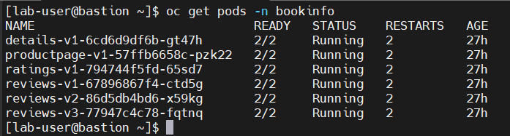

Step 7 — Create Gateway and VirtualService
Expose the productpage application through the Istio ingress gateway:
cat bookinfo-gateway.yaml
apiVersion: networking.istio.io/v1
kind: Gateway
metadata:
name: bookinfo-gateway
spec:
selector:
istio: ingressgateway
servers:
- port:
number: 80
name: http
protocol: HTTP
hosts:
- "*"
---
apiVersion: networking.istio.io/v1
kind: VirtualService
metadata:
name: bookinfo
spec:
hosts:
- "*"
gateways:
- bookinfo-gateway
http:
- match:
- uri:
exact: /productpage
- uri:
prefix: /static
- uri:
exact: /login
- uri:
exact: /logout
route:
- destination:
host: productpage
port:
number: 9080

# Test application is reachable
curl -I http://$GATEWAY_URL/productpage
# Expected: HTTP/1.1 200 OK with server: istio-envoy header

Step 8 — Create DestinationRules
Define the three versions (subsets) of the reviews service. This is required before applying any traffic management rules:
cat <<EOF | oc apply -n bookinfo -f -
apiVersion: networking.istio.io/v1
kind: DestinationRule
metadata:
name: reviews
spec:
host: reviews
subsets:
- name: v1
labels:
version: v1 # No star ratings
- name: v2
labels:
version: v2 # Black star ratings
- name: v3
labels:
version: v3 # Red star ratings
---
apiVersion: networking.istio.io/v1
kind: DestinationRule
metadata:
name: productpage
spec:
host: productpage
subsets:
- name: v1
labels:
version: v1
---
apiVersion: networking.istio.io/v1
kind: DestinationRule
metadata:
name: ratings
spec:
host: ratings
subsets:
- name: v1
labels:
version: v1
---
apiVersion: networking.istio.io/v1
kind: DestinationRule
metadata:
name: details
spec:
host: details
subsets:
- name: v1
labels:
version: v1
EOF

# Verify all 4 DestinationRules created
oc get destinationrule -n bookinfo

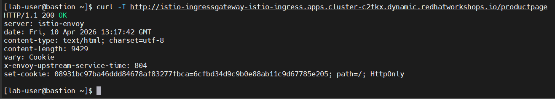

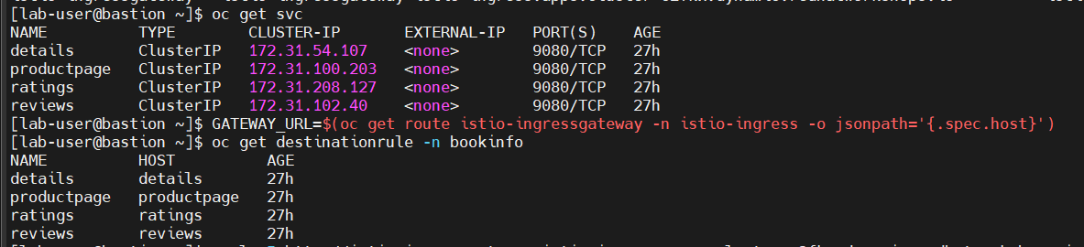

Traffic Management Experiments
All experiments use the Bookinfo application. The reviews service has three versions that produce different visual output, making it easy to verify traffic routing. The application URL for all tests is:

http://istio-ingressgateway-istio-ingress.apps.cluster-c2fkx.dynamic.redhatworkshops.io/productpage
Experiment 1 — Lock All Traffic to v1 (No Stars)
Route 100% of reviews traffic to v1. Since v1 has no star ratings, the page will never show stars regardless of how many times it is refreshed

cat <<EOF | oc apply -n bookinfo -f -
apiVersion: networking.istio.io/v1
kind: VirtualService
metadata:
name: reviews
spec:
hosts:
- reviews
http:
- route:
- destination:
host: reviews
subset: v1
EOF

# Verify — no output means v1 (no glyphicon-star class in HTML)
for i in {1..5}; do
curl -s http://$GATEWAY_URL/productpage | grep -o 'glyphicon-star.*' | head -1
done
# Expected: empty output for all 5 requests

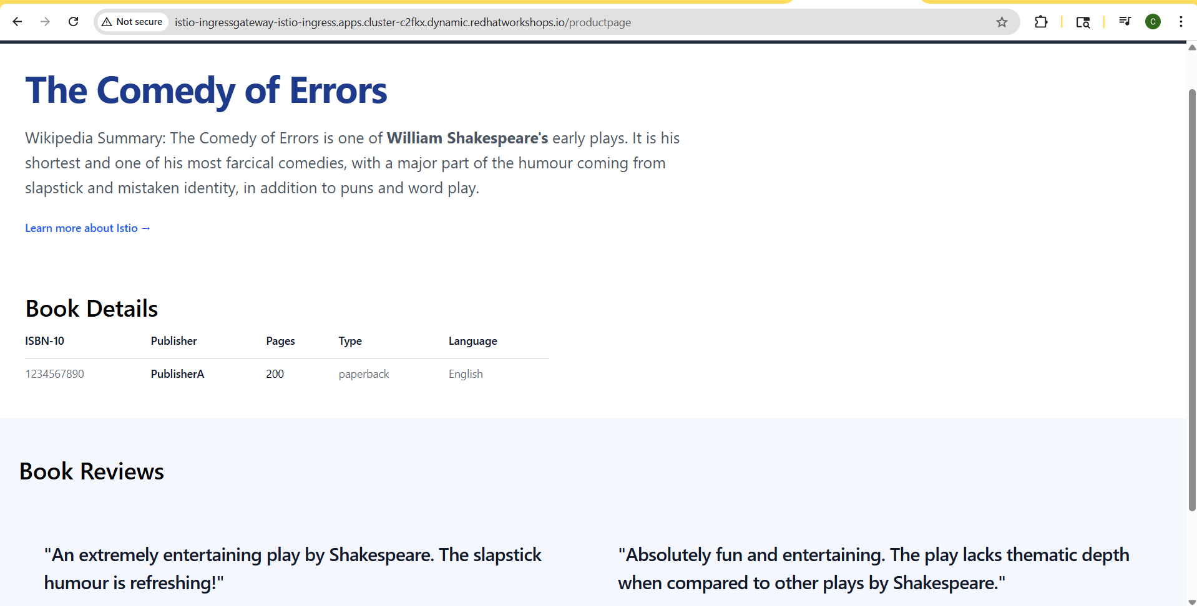

Experiment 2 — 80/20 Canary Release (v1 / v3)(canary deployment)
Split traffic 80% to v1 (no stars) and 20% to v3 (red stars). This simulates a canary release where a new version is gradually rolled out to a small percentage of users.

cat <<EOF | oc apply -n bookinfo -f -
apiVersion: networking.istio.io/v1
kind: VirtualService
metadata:
name: reviews
spec:
hosts:
- reviews
http:
- route:
- destination:
host: reviews
subset: v1
weight: 80
- destination:
host: reviews
subset: v3
weight: 20
EOF

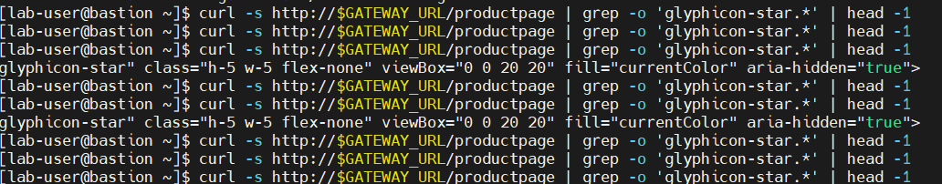
Result: 8/10 to v1 (80%) and 2/10 to v3 (20%). Exactly matches the configured weights.
- By Chinmay Pawar

